Client name | Astral Limited
Project name | UDAY
Module | FI
WRICEF number | 329
Version | V.01
Date | 08.07.2026
Type of development | Report
Complexity | Lowest

Document revision history

Date | Version | Description | Prepared by | Approved by
08.07.2026 | V.01 | Vendor Trial Balance | Bhavin Suthar

Table of content
1 Overview and Scope 3
1.1 Requirement 3
1.2 Assumptions 3
2 Functional Requirements: 4
2.1 Functional Specification: 4
2.2 SECURITY AND AUTHORIZATION 5
3 TESTING REQUIREMENTS 6
3.1 UNIT TEST RESULTS 6

1 Overview and Scope

1.1 Requirement
- Plant wise and state wise vendor trial balance report is required.

1.2 Assumptions
- There is an existing report “ZFI_PCTB_VEND” which provided profit center wise vendor trial balance.
- We are going to use the same report in which we will add business area field, which is equivalent to plant, region code field from profit center master data which will fulfill state wise reporting.
- Requirement is plant wise report. As per KDS, plant = business area and hence we are providing business area field which will fulfill plant wise reporting.
- We are considering region from profit center master data. This will fulfil state wise reporting.
- Business requires as on date balance. There is already document date range selection provided on input screen and based on that date range; system will provide balances. We are not going to change any logic in this, and reporting of balances will remain as it is as per old report.

2 Functional Requirements:

Business requires plant wise and state wise vendor trial balance.

Plant wise: as per KDS plant and business area has one to one relation. Hence, if for example plant “X” is created in the system, business area “X” will be created.

State wise: For state wise reporting, we are considering region provided in profit center master. Current report is already providing profit center wise report.

Current Report T-code: ZFI_PCTB_VEND

Above ECC report is already retrofitted in S4 HANA till QAS and not moved to PRD.

Existing Screen:

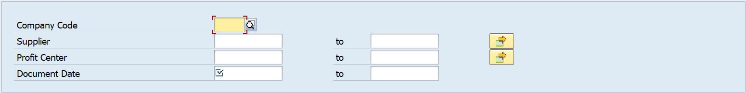

Proposed Screen:

Keep existing screen as it is and add below fields in addition to existing fields selection:
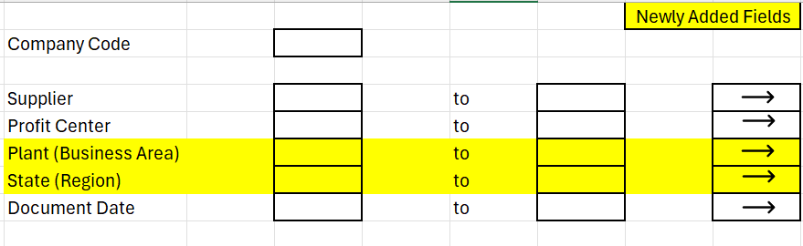

2.1 Functional Specification:

Logic:

- In existing report, documents are already fetched at “PRCTR” field level.
- Add another field “GSBER” = Business Area in existing report logic.
- On input screen we will provide field as a “Plant” however in backend we will provide data from “GSBER – Business Area”.
- Second field is state. To get this field take get “PRCTR” from existing report logic, provide PRCTR in table “CEPC” and get “REGIO”.
- We will show field name State at front end and fetch region as per above logic in backend.
- Other than above additions, all the logic in existing report will remain as it is.

2.2 SECURITY AND AUTHORIZATION

Authorization TBD

3 TESTING REQUIREMENTS
- After adding both the field provided in the requirement, need to check whether business area and region column showing the result for each line item fetched. Business area field is mandatory in all FI postings and hence it should not be blank in any fetched document.
- However, region in profit center master data is user maintenance. If user has not maintained region in profit center master, that field will come blank.
- If we select region “GJ”, we should get all profit center line items which are falling under GJ region.

3.1 UNIT TEST RESULTS
This section will be completed during the unit testing phase by the ABAP developer and functional consultant.

